Muhammad Abdullah

SE(6A) | 19F-0916

Computer Networks Lab

Lab 13: Vlan

**TASK 1 SINGLE SWITCH**

Main Topology

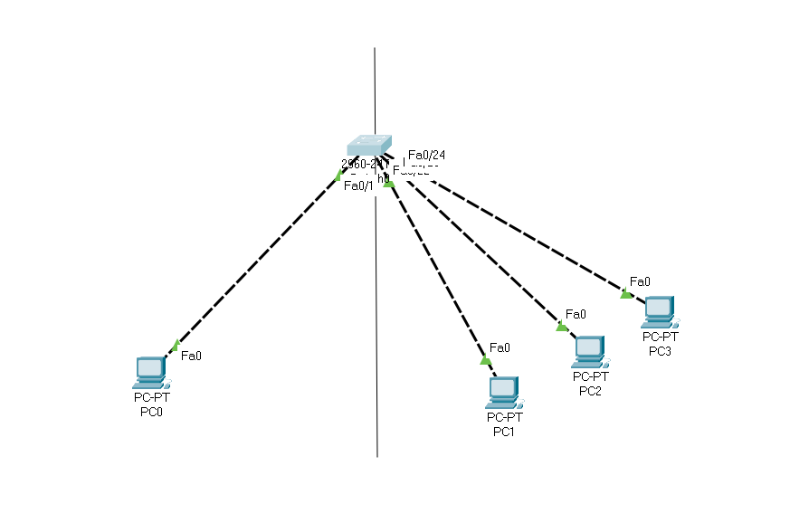

Left Side is for VLAN 10 = HR

Right Side is for VLAN 20 = Services

Switch Configuration

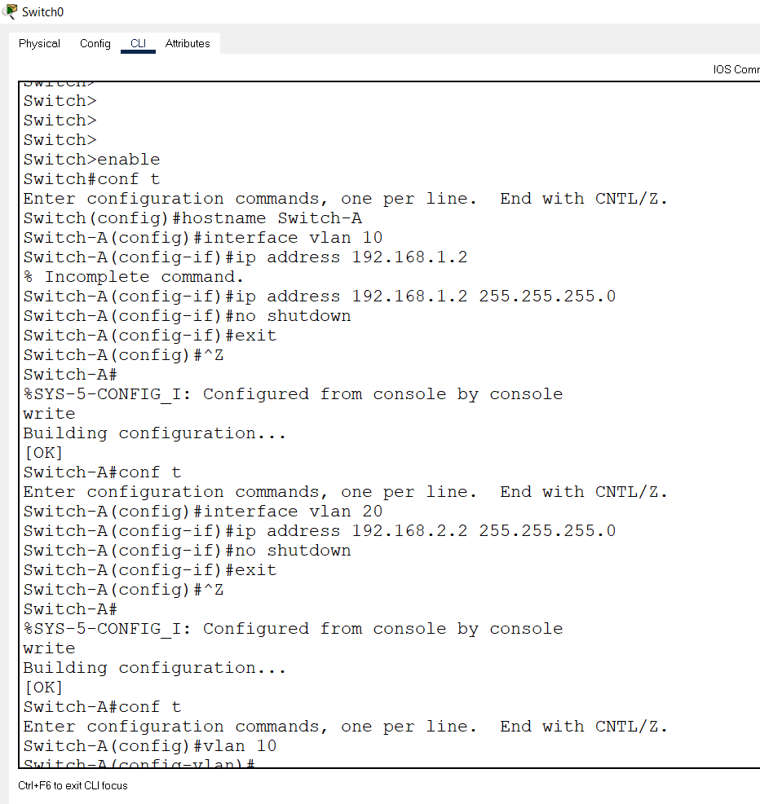

Switch Configuration (Remaining)

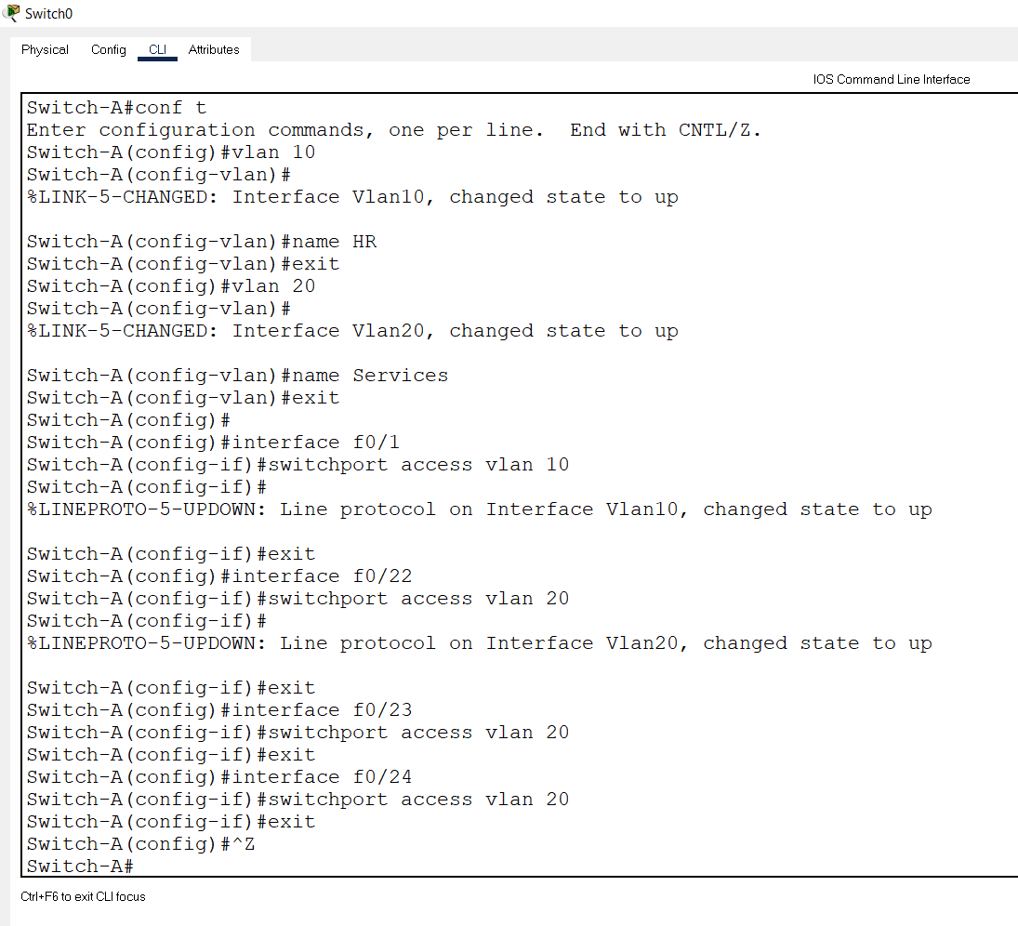

PC 1 Configuration for VLAN 10

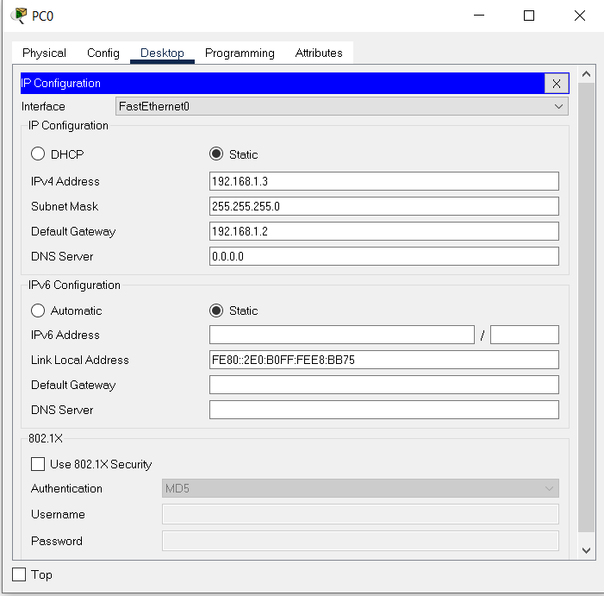

PC 1 Configuration for VLAN 20

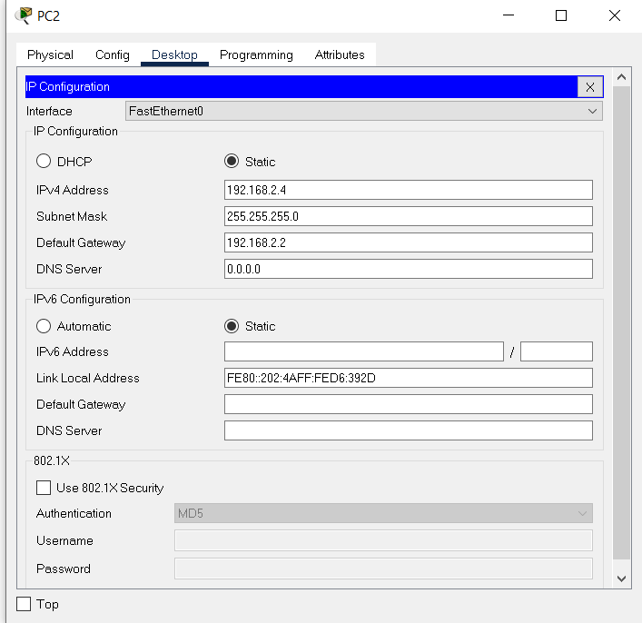

PC 2 Configuration for VLAN 20



PC 3 Configuration for VLAN 20

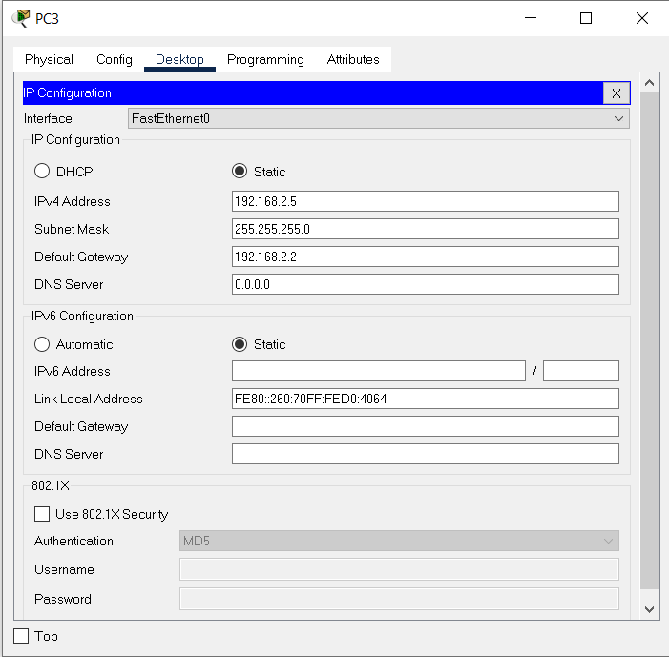

Message Transferring

According to the Concept,

From PC 1 HR to PC 1 Services

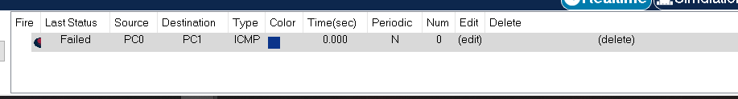

From PC 1 Services to PC 2 Services

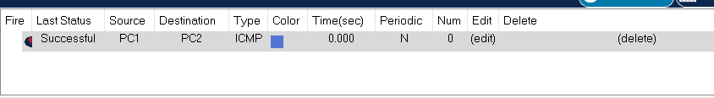

**TASK 2 Double SWITCH**

Main Topology

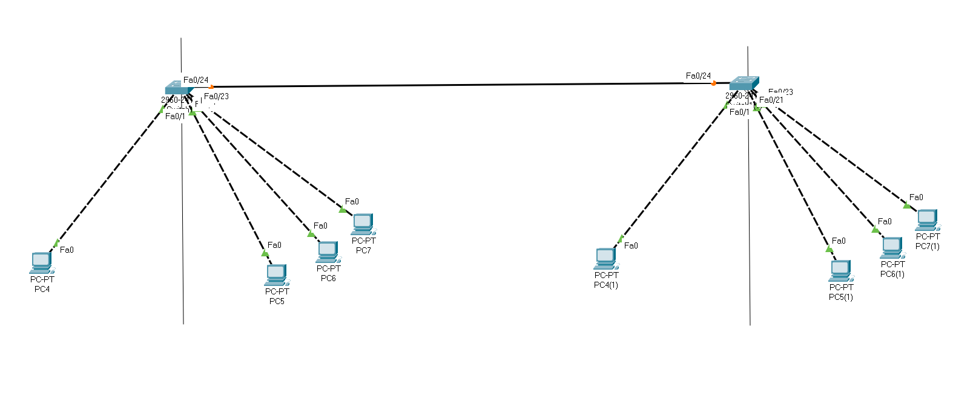

This Task is same as, Task 1 But it is with 2 Switches, rest of the concept is same here in terms of HR VLAN and Services VLAN

Left Side is for VLAN 10 = HR

Right Side is for VLAN 20 = Services

Switch 1 Configuration for VLAN

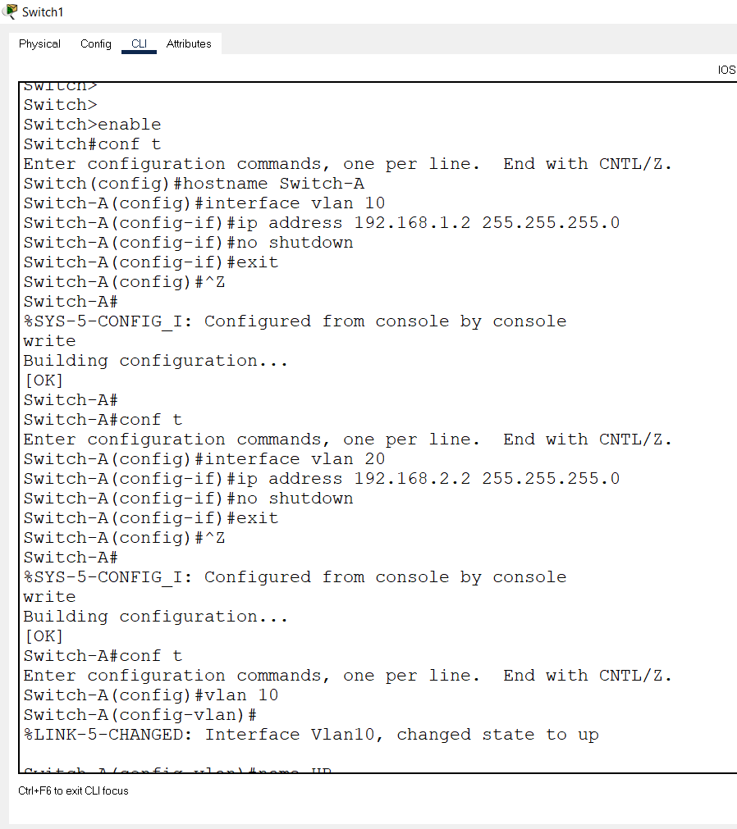

Switch 1 Configuration for VLAN (Remaining)

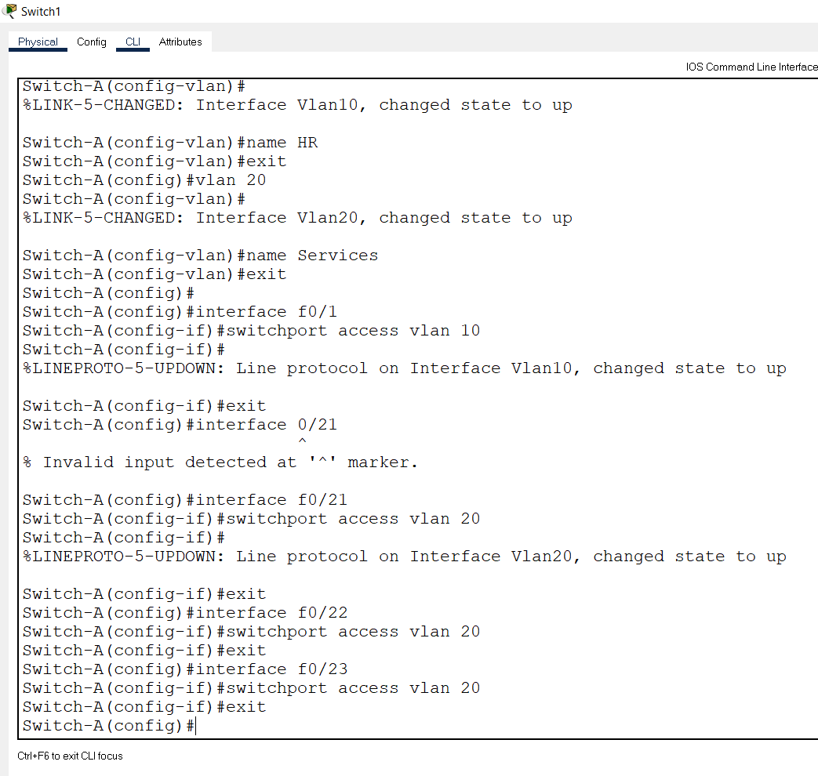

Switch 2 Configuration for VLAN

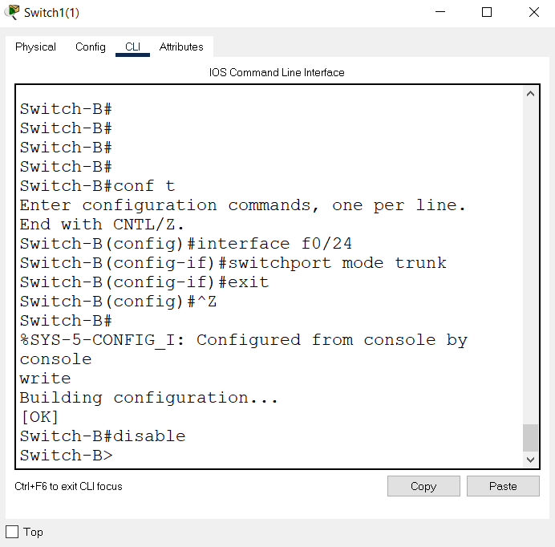

Rest of the configuration is same as Switch 1 Configuration

PC 1 Configuration for VLAN 10 Switch 1



PC 1 Configuration for VLAN 20 Switch 1



PC 2 Configuration for VLAN 20 Switch 1



PC 3 Configuration for VLAN 20 Switch 1



Switch 2 Computer’s Configuration is Same as Switch 1 Computers Hence it is not included here.

Message Transferring

According to the Concept,

From PC 1 HR to PC 1 Services

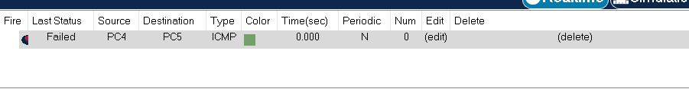

From PC 1 Services to PC 2 Services

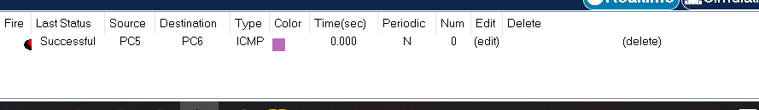

From PC 1 Services to PC 1 Services of 2nd Switch

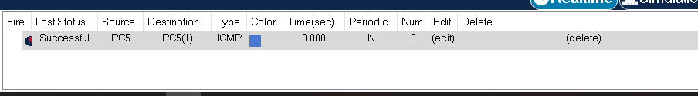

**TASK 3 Triple SWITCH**

Main Topology

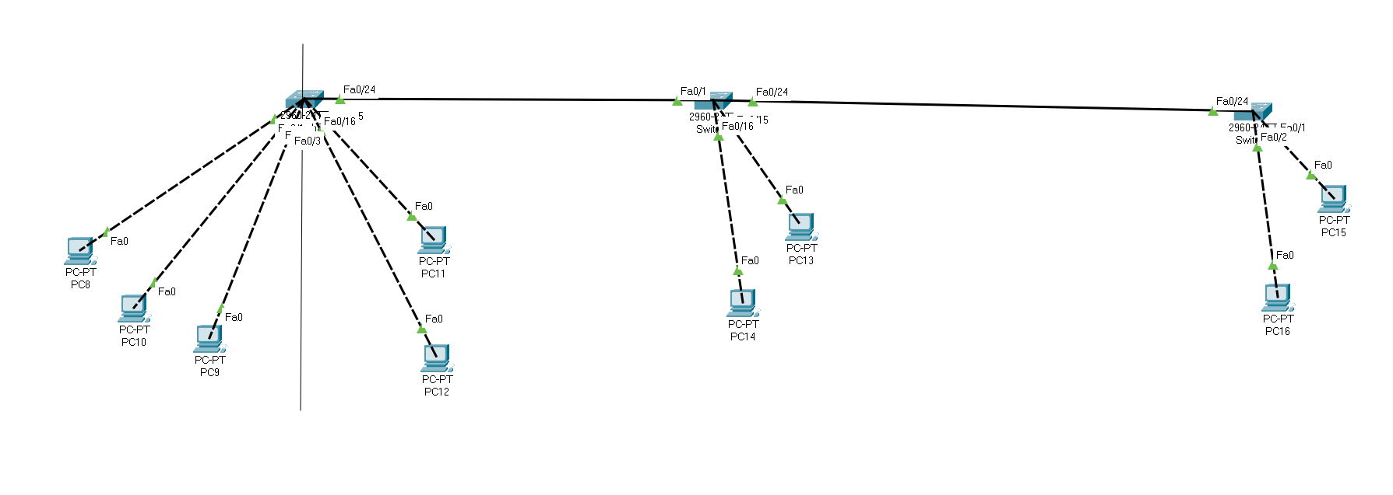

This Task is same as, Task 1 But it is with 3 Switches, rest of the concept is same here in terms of HR VLAN and Services VLAN but here HR converts into HRandFin and Services Converts into Call-Center

Left Side is for VLAN 10 = HRandFin

Right Side is for VLAN 20 = Call-Center

Switch 1 Configuration for VLAN

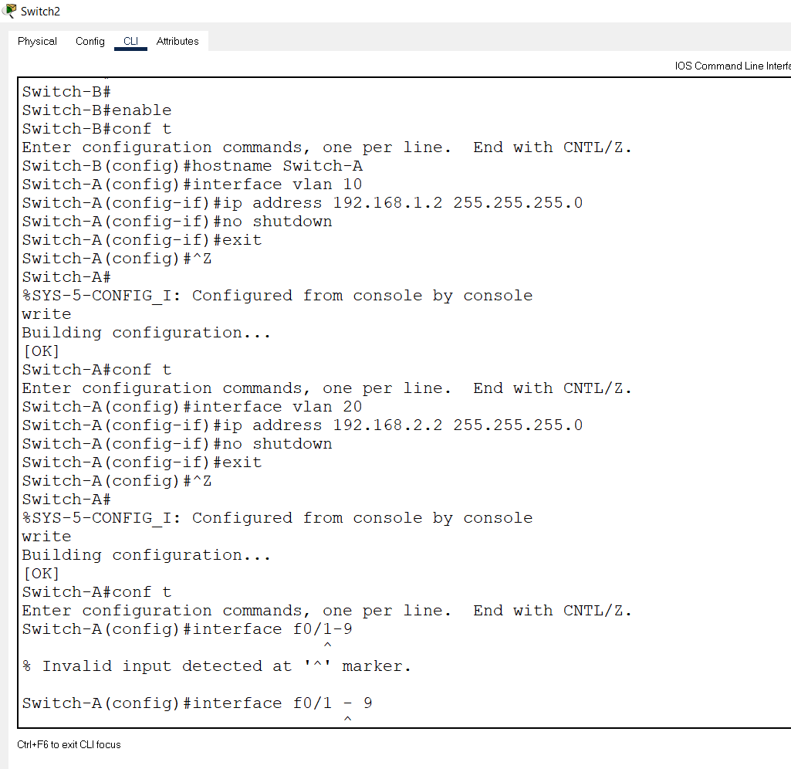

Switch 1 Configuration for VLAN (Remaining)

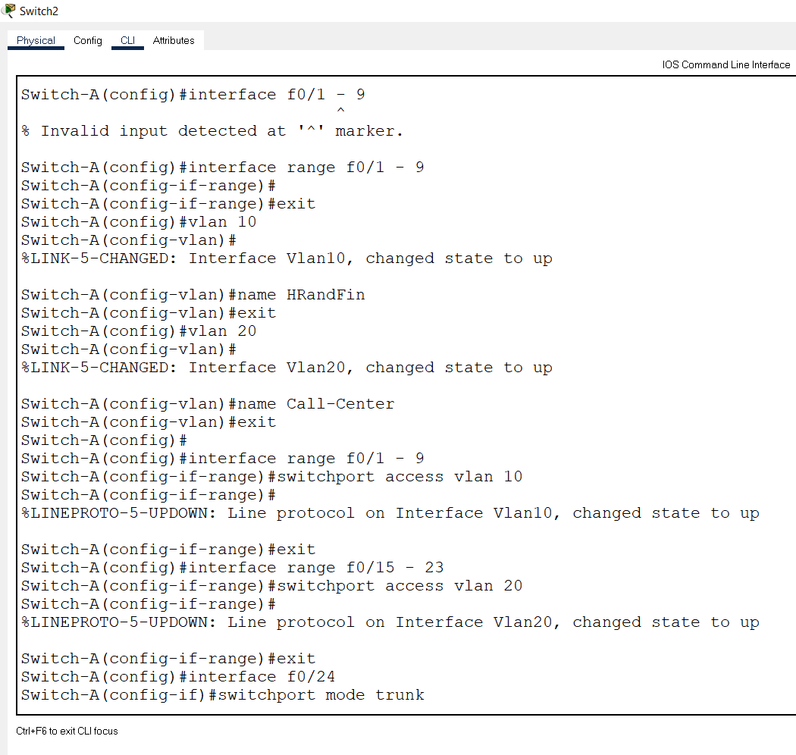

Switch 1 Configuration for VLAN (Remaining)

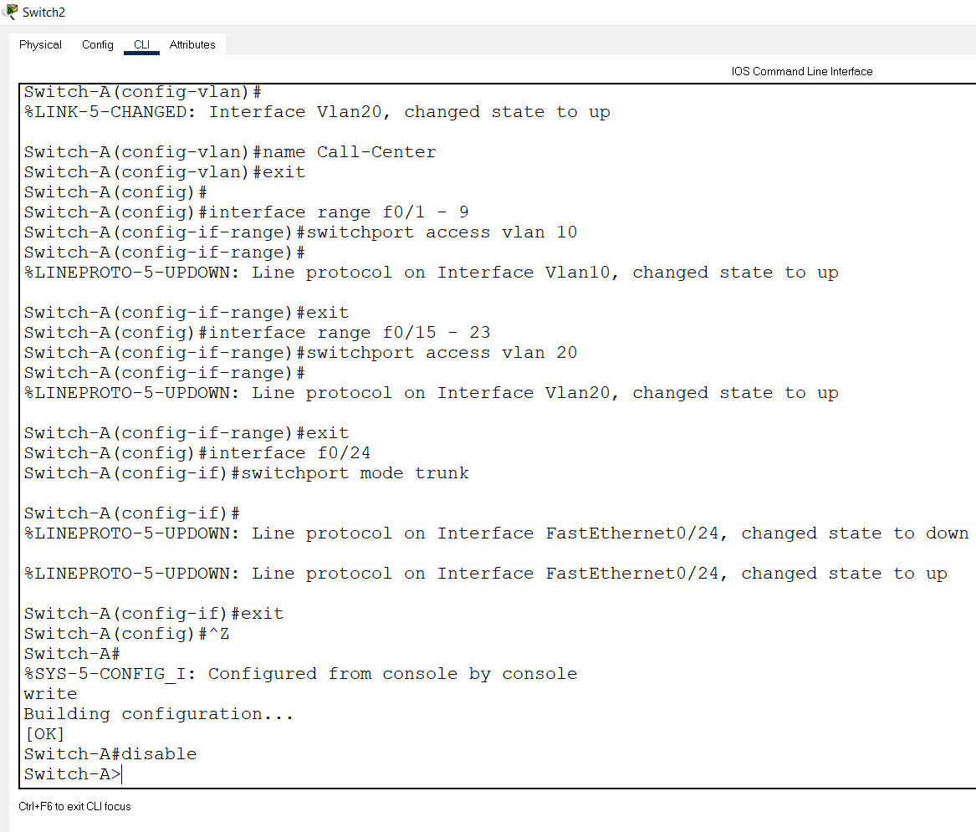

Switch 2 Configuration for VLAN

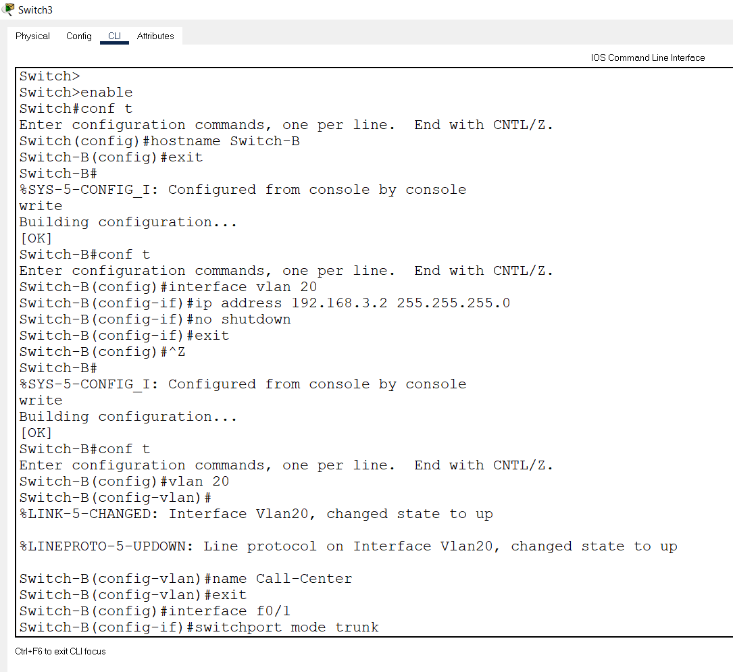

Switch 2 Configuration for VLAN (Remaining)

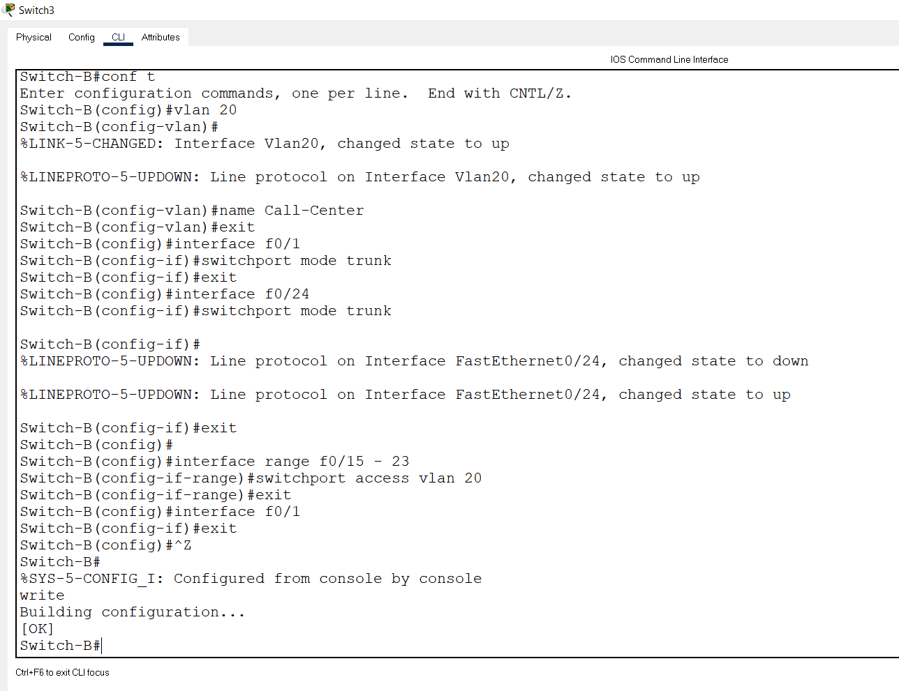

Switch 3 Configuration for VLAN

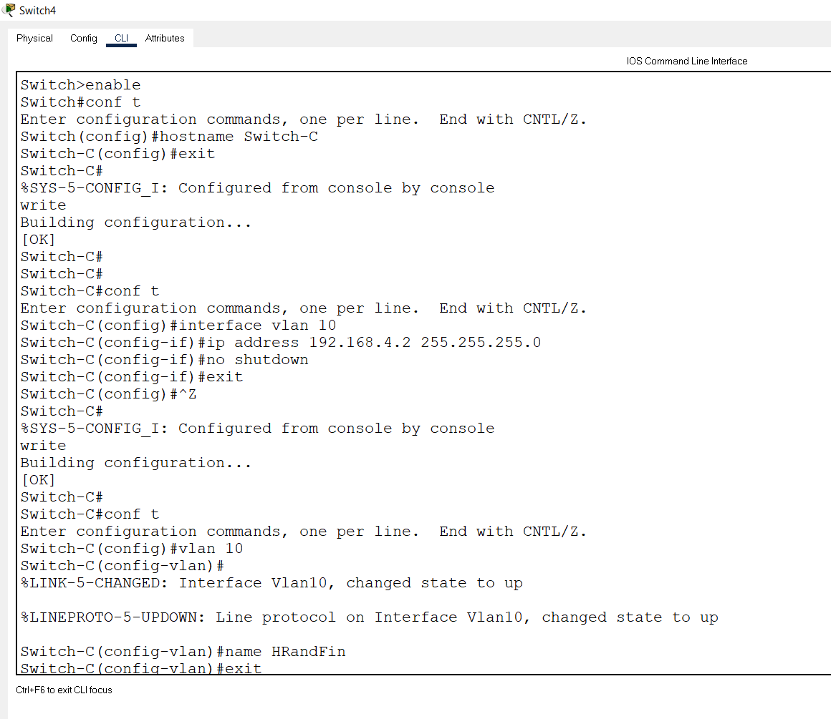

Switch 3 Configuration for VLAN (Remaining)

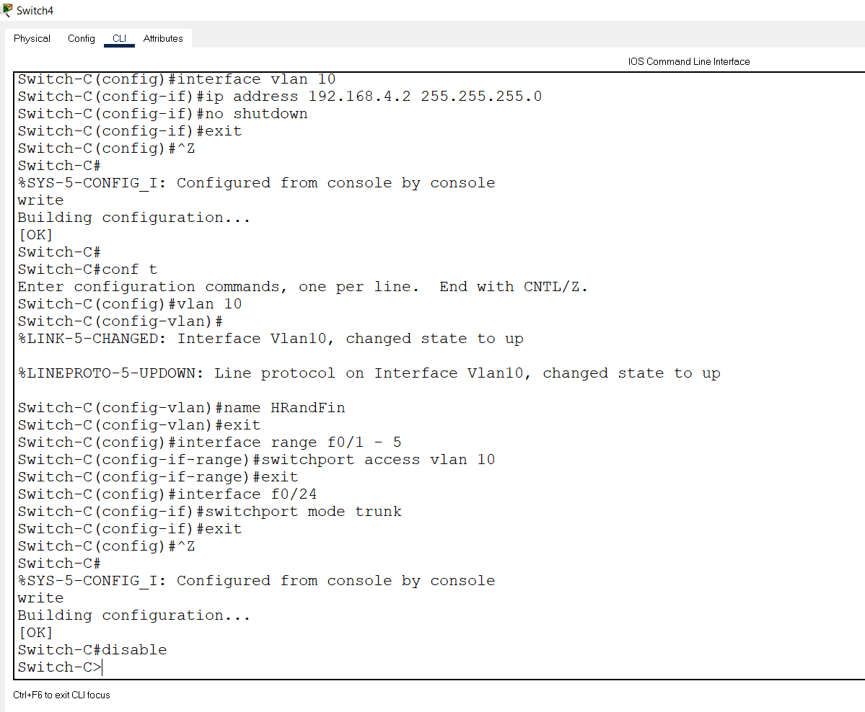

PC 1 Configuration for VLAN 10 Switch 1

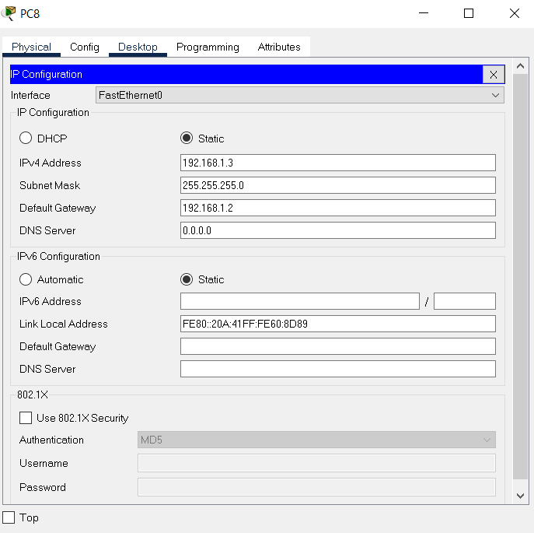

Switch 2 and Switch 3 Computer’s Configuration is Same as Switch 1 Computers Hence it is not included here. Only IP changes for each PC but concept remains the same here.

Message Transferring

According to the Concept,

From PC 1 Call-Center to PC 1 Call-Center

